7516 Colorado Ave. N.
Brooklyn Park, MN 55443
763-566-6536
www.onpointquilter.com
onpointquilter@comcast.net
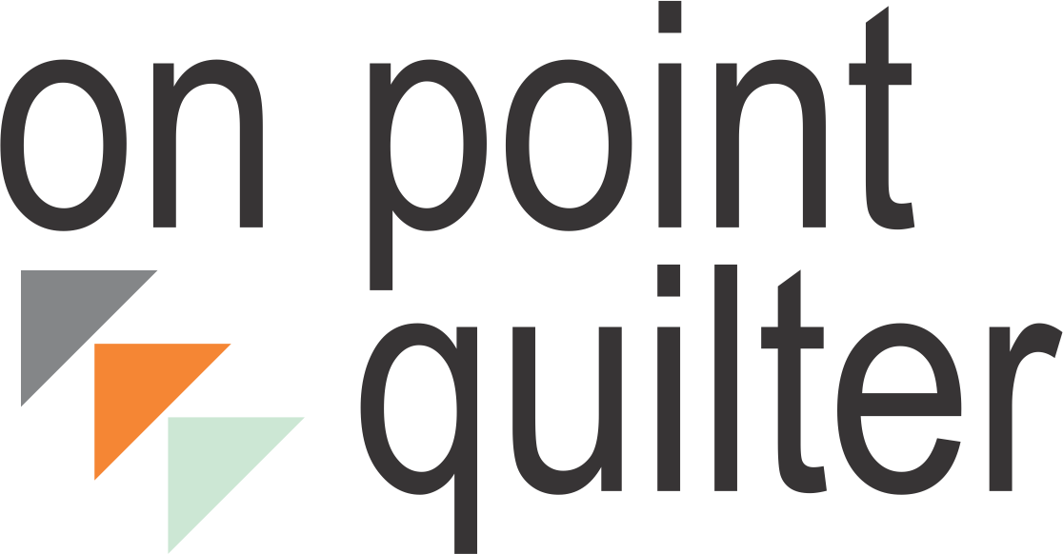
Love your EQ Private Coaching
Sign-Up

Name: ______________________________________________
Business Name (if applicable): _________________________
Phone #: __________________________________________
Alternate Phone #: ___________________________________
E-mail Address: _____________________________________

I am interested in the following:
- Three month coaching program with one-time payment ($250).
- Three month coaching program installment plan (Three payments of $100 per month).
- Six month coaching program with one-time payment of $450.
- Six month coaching program installment plan (Three payments of $170 per month).

Bills for requested services will be sent to you from my PayPal account. You can pay by PalPal or by major credit card. Early bird discounts will be applied for applications received by October 30, 2015.

Electric Quilt Desired Focus Areas:
_____________________________________________________________________________________________________________________________________________________________________________________________________________

Preferred Start Date: __________________________________

Best Day/Time Options for Recurring Sessions (Days, Evenings, Weekends, Week Days):
- Choice #1_____________________
- Choice #2_____________________
- Choice #3_____________________
If none of these choices are available for me, I will provide a number of different options for you to choose from.

I have read the program description along with frequently asked questions and am in agreement.
Signatures:

____________________________ ____________________________
Client Name and Date Kari Schell and Date

